Tectonics - Plate Boundaries

Divergent Plate Boundaries
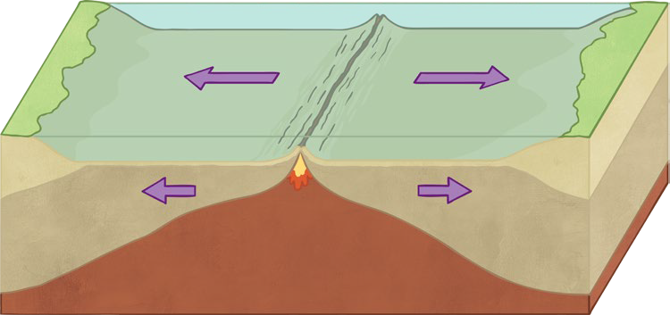
Plates move apart because .
is an example of this type of boundary.

This is where two plates move together / apart. Usually, this occurs under the .
As the plates pull apart, rises and creates .
Some volcanoes grow so large they rise above sea level to form e.g. Iceland. As the plates pull apart, they get stuck; pressure builds up and they trigger .

Convergent Plate Boundaries
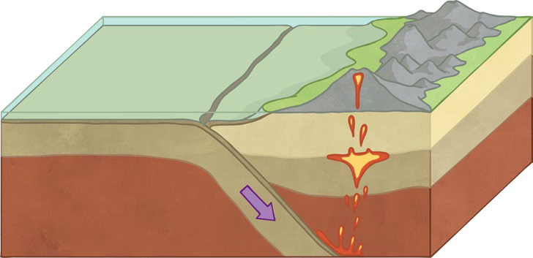
The crust subducts because it is more/less dense. An example of this plate boundary is found in .

This is where two plates together.
The plate sinks and melts to create which rises to the surface to form
.
If the plates get stuck together, builds up until it is released and an occurs.
Tectonics - Plate Boundaries

Conservative Plate Boundaries
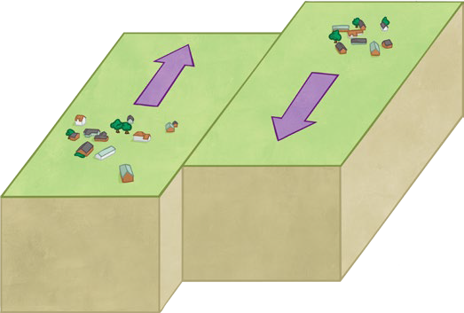

At these boundaries, plates past each other.
The build-up of pressure and friction leads to . As no magma is created, there are no .

